Name-Ayan Sadhukhan

Regd No-19BEC1448

*Project Title:*

**Writing 1/2 as a sum of inverse squares**

*Problem Statement:*

There are several ways to write the number 1/2 as a sum of inverse squares using distinct integers.

For instance, the numbers {2,3,4,5,7,12,15,20,28,35} can be used:

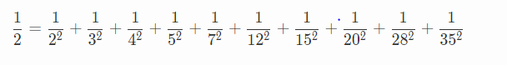

In fact, only using integers between 2 and 45 inclusive, there are exactly three ways to do it, the remaining two being: {2,3,4,6,7,9,10,20,28,35,36,45} and {2,3,4,6,7,9,12,15,28,30,35,36,45}.

How many ways are there to write the number 1/2 as a sum of inverse squares using distinct integers between 2 and 80 inclusive?